**Date: 18/04/2023 (dd/mm/yy)**

**Maria Ginaldi**

A shop sells a range of mobile devices, SIM cards and accessories as shown in the table:

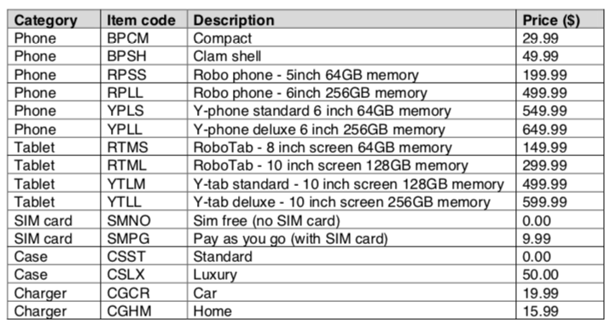

Write a program algorithm for this shop.

▪  Your program or programs must include appropriate prompts for the entry of data; data must be validated on entry.

▪  Error messages and other output need to be set out clearly and understandably.

▪  All arrays, variables, constants and other identifiers must have meaningful names.

You will need to complete these three tasks.

**Task 1 – Setting up the system.**

Write a program to:

▪  use appropriate data structures to store the item code, description and price information for the mobile devices, SIM cards and accessories;

▪  allow the customer to choose a specific phone or tablet;

▪  allow phone customers to choose whether the phone will be SIM Free or Pay As You Go;

▪  allow the customer to choose a standard or luxury case;

▪  allow the customer to choose the chargers required (none, one or both may be purchased);

▪  calculate the total price of this transaction;

▪  output a list of the items purchased and the total price.

**Task 2 – Allow a customer to order multiple mobile devices. Extend Task 1 to:**

▪  offer the customer the opportunity to purchase an additional mobile device;

▪  if required, perform bulleted steps 2 to 7 of Task 1 for each additional mobile device and calculate a running total for the customer;

▪  once no further devices are required, output the total the customer will need to pay.

**Task 3 – Offering discounts.**

Extend the program to allow a discount of 10% off the price of every additional phone or tablet purchased. Output the new total the customer will need to pay and the amount of money saved.